 |  | Name: | ___________________________________________________ |  |  | Date: ___________
 |  |  | Year 12 Essentials Mathematics  Test 1, 2018  Topic –Pythagoras’ Theorem and Trigonometry |  |  | 45  = %
 |  | Total Time: | 50 minutes
 |  | Total Reading: | 5 minutes
 |  | Total Working: | 55 minutes
 |  | Weighting: | 5% of the year.
 |  | Equipment: | 1x A4 page notes (front and back), Scientific Calculator

Full working out must be shown to get full marks.

All units must be noted or marks will be deducted.

Attempt all questions

1. | [6 marks: 3,3]
 | Determine the value of the pronumeral in each of the following HINT Use Pythagoras Theorem
a) | 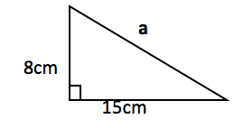
b) | 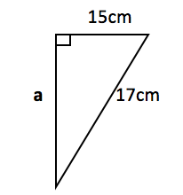

2. | [3 marks: ]
A fireman has a ladder that is 13 metres long. If he wants to reach a window that is 12 metres above the ground, how far from the wall should he put the bottom of his ladder?
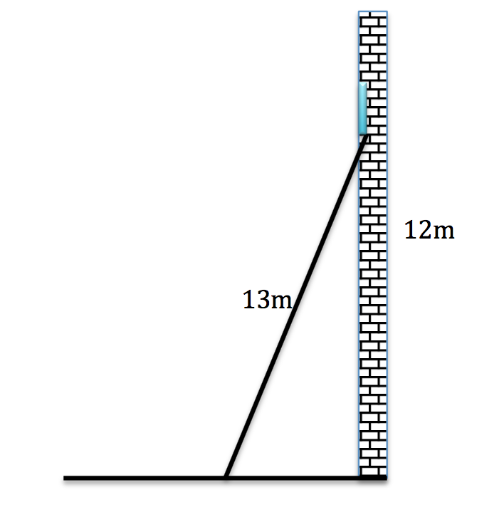

3. | [3 marks: ]
Laura is buying a television. It has a 34 inch screen. If it is 16 inches tall, how wide is the screen? Her television cabinet is 19 inches wide. Will the television fit in it?
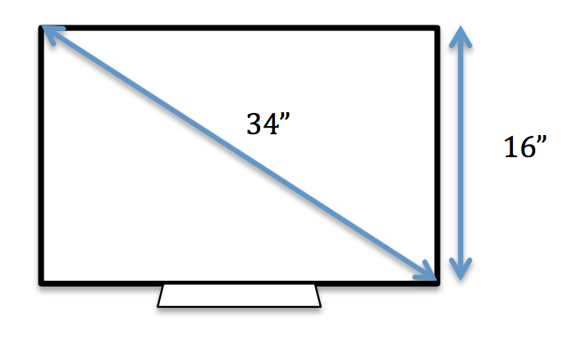

4. | [2 marks: 1, 1]
 | Label the sides Hypotenuse, Opposite and Adjacent sides on the following right angled triangles:
 | a)  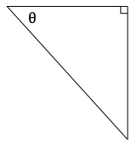 | b)  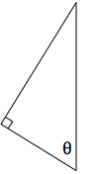

5. | [2 marks: 1, 1]
 | Label the angle in the correct place on the following right angled triangles:
a) | 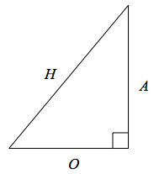 | 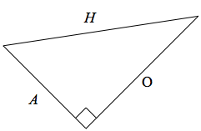

6. | [9 marks, 3, 3, 3, ]
 | Determine the value of the pronumeral in each of the following HINT Use Trigonometry
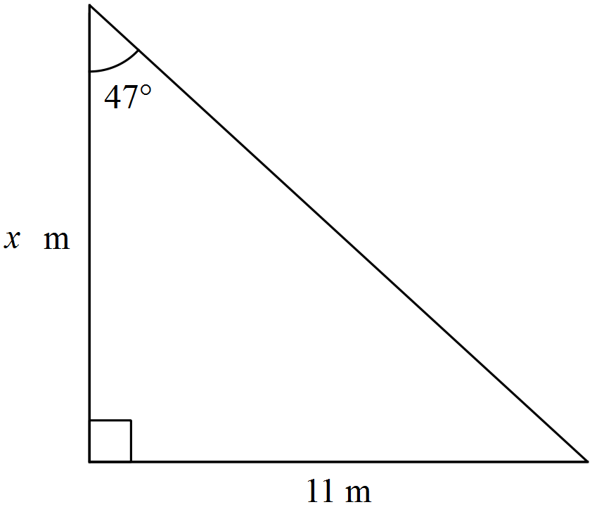
Hint: find the missing angle.
$$θ$$

23m

7. | [3 marks ]
 | A boy notices a bird sitting at the very top of a 10m tall tree. If he is standing 8m from the base of the tree, what is the distance between his eye and the top of the tree?

8. | [4 marks ]
The school council needs to have a ramp build over the steps of each of the building exits, to accommodate a student in a wheelchair. If the junior school building is 35cm off the ground and has steps that reach out 50cm, calculate the length of the ramp
(Sketch a diagram of the scenario).

9. | [3 marks ]
 | A 25 m flagpole casts a 42 m shadow. What is the angle the sun makes with the flagpole
 | 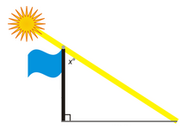

10. | [4 marks ]
From the top of a 25 m lighthouse, on a 314 m tall cliff, the angle of depression to a sailing boat out in the ocean is 40°. How far is the sailing boat from the base of the cliff?
(Sketch a diagram of the scenario).

11. | [6 marks ]
 | From an observer at O who is 200m from a building, the angles of elevation to the bottom and top of a flagpole are 36º and 38 º respectively. Find the height of the flagpole.
 | 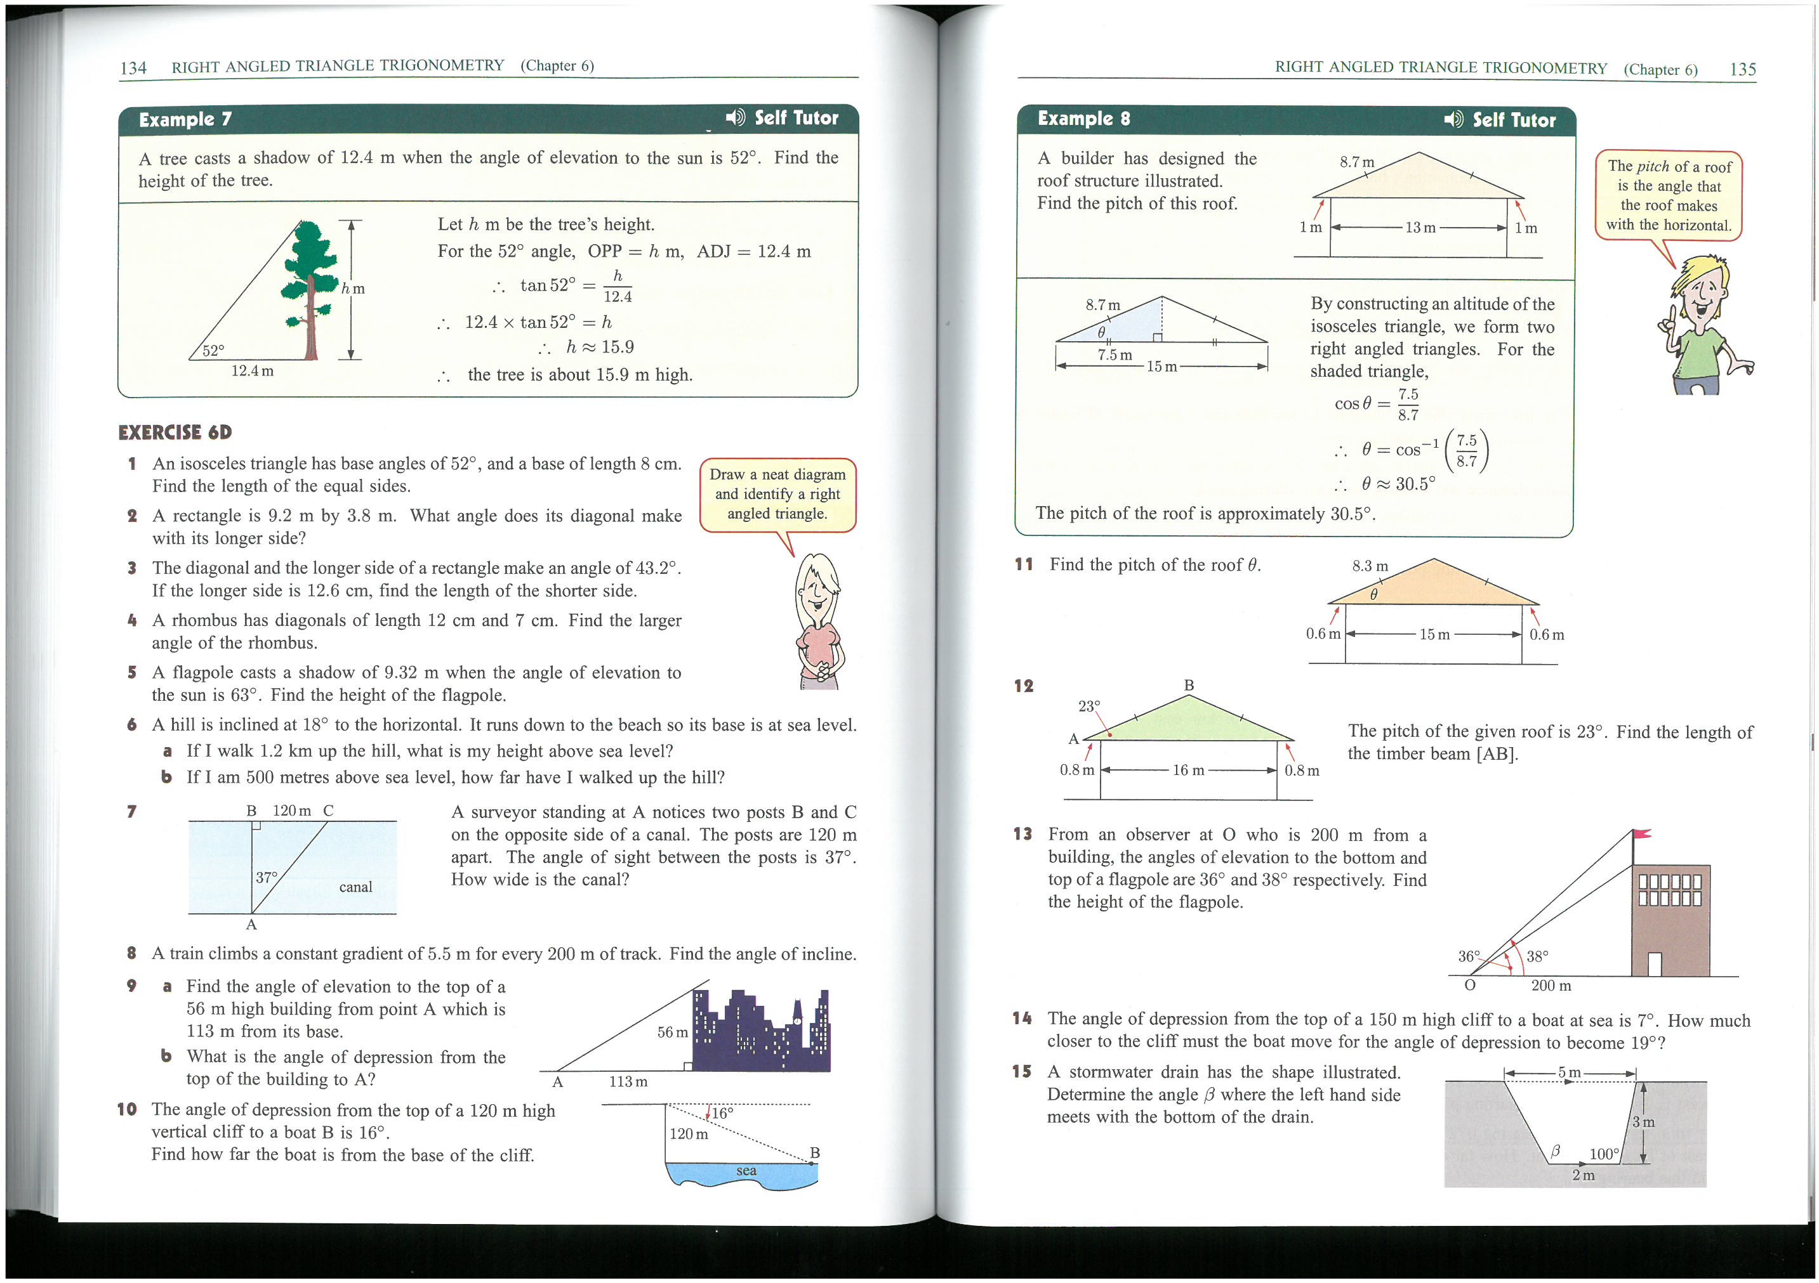

~ END OF TEST ~

